Lesson 2 HW (Alex Doge) 00-580012F (Alexander Zen Taniguchi-Wiegman)
Full listing of code used (copied from R Program History)
R version 3.2.5 (2016-04-14) -- "Very, Very Secure Dishes"
Copyright (C) 2016 The R Foundation for Statistical Computing
Platform: x86_64-w64-mingw32/x64 (64-bit)

R is free software and comes with ABSOLUTELY NO WARRANTY.
You are welcome to redistribute it under certain conditions.
Type 'license()' or 'licence()' for distribution details.

Natural language support but running in an English locale

R is a collaborative project with many contributors.
Type 'contributors()' for more information and
'citation()' on how to cite R or R packages in publications.

Type 'demo()' for some demos, 'help()' for on-line help, or
'help.start()' for an HTML browser interface to help.
Type 'q()' to quit R.

> data <- read.csv("C:/Users/Public/MLG/GetRektSchoolData/school_data.csv", header=T)
> mean(data$school_A)
[1] 38.23714
> table(data$school_A)

31.5 32.7 33.1 33.2 34.2 34.3 34.7 35.1 35.2 35.3 35.4 36.1 36.2 36.3 36.4 36.5
1 1 1 1 1 1 1 2 1 1 1 1 1 1 1 2
36.6 37.1 37.2 37.3 37.4 37.5 37.6 37.8 38.1 38.2 38.3 38.4 38.5 38.6 38.7 38.8
1 3 1 1 2 1 2 1 2 1 1 1 1 2 2 2
38.9 39.3 39.4 39.5 39.6 39.7 39.8 39.9 40.2 40.3 40.4 40.5 40.6 40.8 41.4 41.5
2 1 1 1 2 1 1 2 1 1 2 1 1 1 1 1
41.6 41.7 41.8 42.2 42.4 42.6 43.1 43.3
1 1 1 1 1 1 1 1
> median(data$school_A)
[1] 38.45
> var(data$school_A)
[1] 6.724977
> SS <- sum ((x-mean(data$school_A))^2)
Error: object 'x' not found
> SS <- sum ((data$school_A - mean(data$school_A))^2)
> sum (data$school_A >0)
[1] 70
> SS <- sum ((data$school_A-mean(data$school_A))^2)
> SS
[1] 464.0234
> #Learning a bit more about the program and what sum actually means.
> sd(data$school_A)
[1] 2.593256
> sqrt(var(school_A))
Error in is.data.frame(x) : object 'school_A' not found
> sqrt(var(data$school_A))
[1] 2.593256
> #Oops. A bit of an error there.
> hist(data$school_A, breaks=30:45, col="grey")
> #Graph sucessfully is displayed.
> #End of First part of program to analyse the data of School A.
> #Start of second part of program to analyse the data of School B.
> mean(data$school_B)
[1] 38.24
> table(data$school_A)

31.5 32.7 33.1 33.2 34.2 34.3 34.7 35.1 35.2 35.3 35.4 36.1 36.2 36.3 36.4 36.5
1 1 1 1 1 1 1 2 1 1 1 1 1 1 1 2
36.6 37.1 37.2 37.3 37.4 37.5 37.6 37.8 38.1 38.2 38.3 38.4 38.5 38.6 38.7 38.8
1 3 1 1 2 1 2 1 2 1 1 1 1 2 2 2
38.9 39.3 39.4 39.5 39.6 39.7 39.8 39.9 40.2 40.3 40.4 40.5 40.6 40.8 41.4 41.5
2 1 1 1 2 1 1 2 1 1 2 1 1 1 1 1
41.6 41.7 41.8 42.2 42.4 42.6 43.1 43.3
1 1 1 1 1 1 1 1
> #oops wrong school. We did this already.
> table(data$school_B)

29.5 31.7 32.1 32.5 32.8 33.1 33.3 33.7 33.8 33.9 34.7 34.8 34.9 35.2 35.3 35.4
1 1 1 1 1 1 1 1 1 1 2 1 1 1 1 3
36.2 36.4 36.6 36.7 36.8 37.1 37.3 37.4 37.5 37.7 37.8 38.1 38.2 38.4 38.6 38.7
1 1 1 1 2 1 2 1 2 1 1 2 1 1 1 2
38.8 38.9 39.4 39.5 39.6 39.7 39.8 39.9 40.1 40.3 40.4 40.5 40.7 41.4 41.5 41.6
2 1 1 1 2 1 1 1 2 1 1 1 1 1 1 1
41.8 42.5 42.6 43.7 44.4 44.5 45.1 45.6 46.1 47.3
1 2 1 1 1 1 1 1 1 1
> #much better
> median(data$school_B)
[1] 38.15
> #This matches expectation. Continuing.
> var(data$school_B)
[1] 13.56765
> SS <- sum ((data$school_A-mean(data$school_B))^2)
> SS
[1] 464.024
> #copy and paste error - hence, a good reason to check work after inputting commands
> SS <- sum ((data$school_B-mean(data$school_B))^2)
> SS
[1] 936.168
> #Again, better.
> sd(data$school_B)
[1] 3.683429
> sqrt(var(data$school_B))
[1] 3.683429
> #Numbers match each other. Continuing...
>

> #Running MLG Doge GetRekt program to hack the image for Histogram data$school_A into that for Histogram data$school_B
> #For an intro on Doge, please visit http://barkpost.com/understand-the-doge-meme-in-7-easy-steps/
> #To watch a funny MLG video go to https://www.youtube.com/watch?v=vz7LupqVMqM
> #OK, that is now over. Back to work.
>
> hist(data$school_B, breaks=28:50, col="grey")
> #Histogram is successfully displayed.
> #End of program. Summary of data asked for in problem will be created as a chart in MS Word.
>
> #Time to GetRekt Shutdown Command.
> q()

The Results and Graphics (Histograms)
Summary of Results
 | School A | School B
Mean | 38.237 | 38.240
Variance | 6.725 | 13.568
Standard Deviation | 2.593 | 3.683

Histograms are continued on the next page.

Histograms

School A | School B
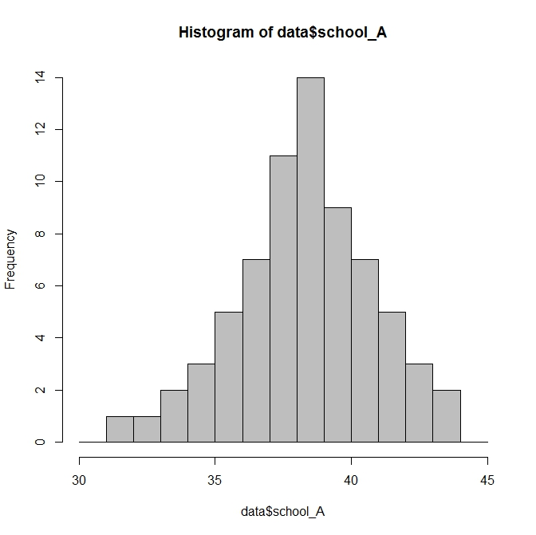 | 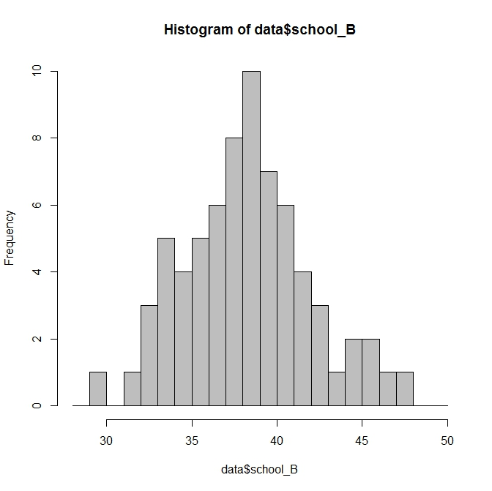

Analysis of Results


In order to fairly compare data sets, we must make sure that some basic premises match. Perhaps one of the first and most important things are dimension – and we can quickly see that both are one-column matrix vectors of one by forty terms. So far, so good – everything is equal magnitude and direction. Unit and vector space-wise as well – These are all values in kg (kilograms) for the vector space of R¹ measuring the weight of 11 year old boys in each school. That aside, the next thing to consider is the data. The means are very similar, to the point where we might as well consider them statistically equivalent. This is sensible, as we assume both schools are nearby each other, and general habits of weight-affecting activities (eating, exercise) are about the same in one specific area (all other variables thought of as negligible or equivalent). It’s quite evident from the somewhat larger values of the variance that it is not in the same kg units as say, how the S.D. would be, but it is a more true representation of the exact spread of the data – if very sensitive as well – with an expansion of only a few whole numbers on each side of the spectrum, the variance slightly more than doubles! It’s a very sensitive, and therefore, easy to compare value. As mentioned, however, it’s the S.D. that is easier to use, because it is in the kg unit form, and will tell us what percentage of most data is within one, two, or three data points, as both curves roughly resemble some form of empirical “bell-curve” distribution. Any values outside of a certain amount of standard deviation could even be recognized, and then removed from further data calculations as “outliers” in this method. Overall, it was rather easy to make the computer do the work to find the values and seeing all the values in front of me at once makes it easier to see connections between the data.

